Database with VIEW and INDEX

AIM:
To create view and index on the given relation.
DESCRIPTION:
VIEW:
MySQL has supported database views since version 5+. In MySQL, almost features of views conform to the SQL: 2003 standard. MySQL processes query against the views in two ways:
- In a first way, MySQL creates a temporary table based on the view definition.
- Statement and executes the incoming query on this temporary table.
- In a second way, MySQL combines the incoming query with the query defined the view into one query and executes the combined query.
SYNTAX- VIEW:
CREATE [ALGORITHM = {MERGE | TEMPTABLE | UNDEFINED}]
VIEW [database_name.]view_name
AS [SELECT statement]
INDEX:
A database index, or just index, helps speed up the retrieval of data from tables. When you query data from a table, first MySQL checks if the indexes exist, then MySQL uses the indexes to select exact physical corresponding rows of the table instead of scanning the whole table.
SYNTAX- INDEX:
CREATE [UNIQUE|FULLTEXT|SPATIAL] INDEX index_name
USING [BTREE | HASH | RTREE]
ON table_name(column_name[(length)] [ASC | DESC], ...)
Questions on View:
- Create a view with name 'v1' using employees1 table which holds the value of employee_id and salary of employee.
- Do the insert and delete records from v1 table.

Question 1

Create a view named juice_view using the juiceshopc table that holds the customer name, juice name and number of juices.
Answer:
CREATE VIEW juice_view AS
SELECT customer_name, juice_name, no_of_juices
FROM juiceshopc;
SELECT * FROM juice_view;
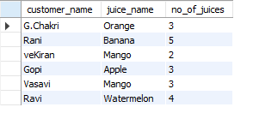
STEP 7 — Question 2

Insert a record through the juice_view and then delete that record from the view.
First, check whether your view allows modification:
SELECT * FROM juice_view;
For a simple updatable view like this, you can try:
INSERT INTO juice_view
(customer_name, juice_name, no_of_juices)
VALUES
('Arun', 'Apple', 2);
Then check:
SELECT * FROM juice_view;

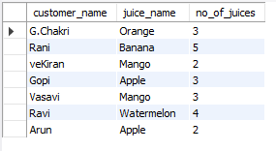
Now delete it:
DELETE FROM juice_view
WHERE customer_name = 'Arun'
AND juice_name = 'Apple';
Check again:
SELECT * FROM juice_view;

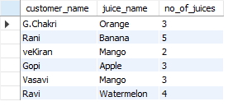

PART B — INDEX
STEP 8 — Understand INDEX
An INDEX helps MySQL find rows faster instead of scanning the entire table.
We will create an index on juice_name.

STEP 9 — Create the index
Run:
CREATE INDEX juice_index
ON juiceshopc (juice_name);

STEP 10 — Check the index
Run:
SHOW INDEX FROM juiceshopc;

STEP 11 — Test the index
Run:
SELECT *
FROM juiceshopc
WHERE juice_name = 'Mango';
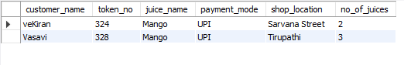
RESULT
The view and index were successfully created on the juiceshopc table. Records were inserted and deleted through the view, and the created index was verified successfully. This follows the View and Index objectives given in Experiment 10 of your lab manual.

